Emerging Technologies in New Media:

(The impact of Social Media & other Emerging Technologies in the fields of Journalism & Broadcasting)

Submitted To: Phillip Doyle & Bob Jackson

Submitted By: Colm Gallagher (T00170514)

Computing with Multi Media

Date Submitted: 7/1/2021

# Abstract

Social media has had a substantial impact on the fields of both the journalism, and broadcasting, industries.

The manner in which people receive news and information has developed rapidly over the course of the twenty-first century. In previous generations, a person would have to wait for timed bulletins, on the hour through the medium of radio, even less frequently on the television. Daily newspapers would often have been the only way to gain any sort of in-depth knowledge on the big local, or global, events of the day.

Since the rise of social networks, and into social media, throughout the past two decades though, readers, listeners, and viewers have amalgamated into *users*. They have become accustomed to being presented with their news instantly through social media platforms which can be easily accessed through whichever new technology they have to hand. The news today could now be seen as ambiguous due to the acceleration of ‘fake news’. Citizen journalism has also come to be commonplace as more people have accessibility to modern technological devices. Advances in science mean that Artificial Intelligence is now becoming a real alternative to human produced journalism and presentation.

The aim of this study is to explore the effects these instances of new media have had, and moving forward, *will* have, on what is generally termed as, traditional media.

Table of Contents

Abstract 2

Background 3

Chapter 1: Social Media Platforms 7

1.1 Introduction 7

1.2 Impact on Traditional Media 7

1.3 Citizen Journalists 9

Chapter 2: Politics and Untruths 12

2.1 Introduction 12

2.2 Political Usage 12

2.3 Disinformation (“Fake news”) 13

Chapter 3: Automated Journalism & Artificial Intelligence 16

3.1 Introduction 16

3.2 Impact on Traditional Media 16

3.3 Controversy 17

Conclusion 19

Tentative Predictions 20

References 21

Bibliography 24

# Background

Some say that the birth of social media was not, as many would believe, in the 21st century; But rather, almost two hundred years ago, in 1844. On May 24th of that year, the first social media message was delivered through electric wires by Samuel Morse. The telegram read:

“What hath God wrought”.

It may be that social media was created along with the invention of Morse Code (Rosenwald, n.d.).

More recently, in 1980, *USENET* became a forerunner to the social networking sites which would soon follow. Three networked computers enabled file sharing as well as message exchanging between founders, Jim Ellis, and Tom Truscott. It was University of North Carolina student, Steve Bellovin, who wrote the original software to enable the process. What was then known as *newsgroups*, would provide numerous discussion boards. Of the modern day websites, *Reddit* would appear to be the most heavily influenced by *USENET*. (USENET | Internet discussion network, 2020).

Often considered to be a pioneer for future social networking sites, and the current generation of social media platforms, *SixDegrees* was launched in 1997. Similar to *Facebook*, it allowed people to connect to ‘friends’ and post messages (McFadden, Christopher, 2020a).

Simeon Edosomwan notes in his dissertation, “The history of social media and its impact on business”:

“In fact, there are several differences between social media and social networks (Hartshorn, 2010). The first one could be the definition; social media is still a media which is primarily used to transmit or share information with a broad audience, while social networking is an act of engagement as people with common interests associate together and build relationships through community (Cohen, 2009; Hartshorn, 2010).” (Edosomwan et al., 2011)

It may be that Social media is a difficult label to categorise as it can be associated with many entities (Newman, Nick, 2020). It could also be stated that new media is just as ambiguous a term, as it would seem to relate to any type of media which is delivered by digital means (Cote, Joe, 2020). Social media as a form of new media would appear to have derived, predominantly, from social networking sites, particularly those coming to prominence in the past ten to fifteen years, approximately.

Reid Hoffman and his peers founded *LinkedIn* in 2003 as a connection platform for professionals to network with one another (Potter, James, 2014). Another 2003 creation was *Facebook*, as *Facemash*, before adopting the name it is known under to this day, in 2004. A brainchild of Mark Zuckerberg, the site’s original concept was to connect fellow Harvard students to one another and share aspects of their everyday lives (Hall, Mark, 2020).

Two years later, in 2006, Jack Dorsey and Biz Stone developed another social networking platform, *Twitter*[1]. Dorsey’s idea was essentially a texting service but one where all texts would be uploaded to a centralised platform for all in a particular social circle to view (Carlson, 2020).

A connecting service which slightly differed from the previous two companies mentioned is *YouTube*. Created between them, in 2005, *YouTube* was strictly a video sharing service as co-founder, Chad Hurley, sensed that it was a medium which wasn’t being highlighted sufficiently on the internet (McFadden, Christopher, 2020b). The first ever video uploaded to the platform was by fellow co-founder, Jawed Karim, on a visit to San Diego zoo (Me at the zoo, 2005). The video would seem to foreshadow the immediacy which has become such a staple of social media in the present day.

It was later on into the existence of these platforms that they came to be established as significant competitors in the news and broadcasting market. The corporations were subsequently joined by other applications such as *Instagram*, *Reddit*, and *WhatsApp*.

During the 2008 U.S. election campaign was when *Facebook* first became noticeable in relation to news, rather than just as a connection tool. (Hall, Mark, 2020). Twelve years later, prolific ‘tweeter’, and current[2] President of the United States, Donald Trump, was using *Twitter* to declare himself the victor in the 2020 election.

This is perhaps an example of new media remediating old media as it is entirely plausible to imagine the following famous telegram message from Mark Twain, in 1897, being posted on *Twitter* today, and going viral:

“Reports of my death are greatly exaggerated”.

A quote uttered by Twain upon hearing about a premature announcement of his death (This week in tech, 2017)

Hypermediacy is a form which is being increasingly used by traditional news media outlets on social media platforms. Many networks such as *CNN* and *BBC* broadcast video clips containing rolling news tickers, statistics, and graphs Etc. (Bolter and Grusin, 1999).

There is also a sense of breaking the fourth wall in regard to the interactivity between journalists or broadcasters, and regular ‘users’ on social media platforms. Engaging with a ‘user’ online who may happen to be a reader, viewer, or listener *offline* gives a sense of immediacy which very likely wouldn’t have happened with traditional media, if at all. Yes, phone-ins and text ‘shout-outs’ were a common occurrence before the dawn of social media, but they didn’t have the intimacy of the latter, as phone-ins would be time limited and text reads were lacking the art of conversing which is far more accessible over media platforms (Barnhart, Brent, 2020). This author has experienced being on both sides of this divide. As a keen listener of radio, many informative conversations have been had with presenters who would have inspired me throughout the years. But also, it has afforded the opportunity to develop relationships with listeners to this author’s shows, dialog that wouldn’t have happened before the advent of social media. These platforms show the broadcaster’s human side and can make them much more *normal* to their audience, and ideally, more appealing to them too (Michel, Oscar, n.d.).

Another technology which has had an impact on journalism is Artificial Intelligence (AI). Although AI has been in operation for many decades, the advancements of the technology in recent times has meant it is having an increasing impact on the manner in which news is being presented. Algorithms have become far more reliable to such an extent that articles can be targeted at specific users of any given social media platform through the process of automated journalism (Brennen, Howard and Nielsen, n.d.).

Artificial intelligence, it is believed, will play a significant role in relation to propaganda and “Fake news” agendas during the, previously mentioned, Presidential campaign for the 2020 U.S. election (Newman, Nick, 2019). The concept of disinformation has received a considerable amount of criticism, to the extent that social media platforms are placing a lot of resources into attempting to filter what is, and isn’t, reputable information. The hope is that they can win back some trust from ‘users’. (Newman, Nick, 2019).

There can be no doubt that social media is now a considerable force which has made traditional media organisations adapt to a new way of broadcasting as they fall further behind in terms of revenue (The Evolution of Social Media: How Did It Begin and Where Could It Go Next?, 2020).

# Chapter 1: Social Media Platforms

## 1.1 Introduction

The evolution of social networking sites into social media platforms has turned the news industry on its head and changed the whole dynamic of how news is both received and delivered. Traditional media has had to radically switch its whole operating model under increasing pressure from these new forms of media. Print media has suffered the hardest and has had to find ways to embrace social media in order to sustain a source of revenue. (Kaul, Vineet, 2020a)

## 1.2 Impact on Traditional Media

Although, as mentioned in the introduction, print media has suffered financially with the advent of social media due to increased competition for readers; it has also taken positives from the situation it has been backed into. For example, the speed with which stories are broken has had one of the biggest impacts on traditional media outlets. Newspaper journalists can now share their articles on social media platforms instantly. This is a big plus for them, but this erases an advantage that broadcast media had held over the print industry in previous eras.

“Local radio used to have the edge, as they could break stories ahead of the papers. They could also hold stories as the only competition was the local paper, but that’s not the case now. Plenty of online news outlets will upload stories as they happen, stories which would have been kept for a slower day in radio” (Mullins, Mary, Radio Kerry Journalist, 2020).

Conversely, the speed of breaking stories may also have a detrimental impact on what is posted. In the rush to beat the competition in getting the story out to a wider audience, the quality of the information supplied may be reduced to necessitate being the journalist / organisation whom broke the story first.

Some would point to the limits of social media in relation to certain topics. Professor of Modern Irish History at UCD, Diarmaid Ferriter, believes, for example, that *Twitter* lacks the ability of broadcast media to bring sufficient context to subjects.

“Isn’t it interesting that the President (Michael D. Higgins) has been using this word, ‘Macnamh’, when he’s talking about how to reflect on the War of Independence? ‘Macnamh’ means thoughtfulness, reflection, mediation…the complete antithesis to Twitter. You’d like to think that they’re (young people) not going to get any kind of a history education from tweets”[3] (*Claire Byrne Live*. (2020), RTE One Television, 7 December).

There are, though, also mutual benefits between the traditional and social platforms. Broadcast and print journalists can reach a wider audience to read, view and listen to their stories through a variety of social networking sites. In the experience of this author, presenters can create far more interactive content for their shows than against the period before social media existed. And, on the other side of it, most of the more prominent social sites receive plenty of free ‘on air’ mentions, driving more people to their platform.

Returning to the financial impact on traditional media, it is evident that social media platforms have dented their revenue streams considerably. One U.S. 2018 survey (Figure 1) shows that marketing companies spent almost as much on online campaigns than they did on the whole of the traditional media outlets combined (The Evolution of Social Media: How Did It Begin and Where Could It Go Next?, 2020).

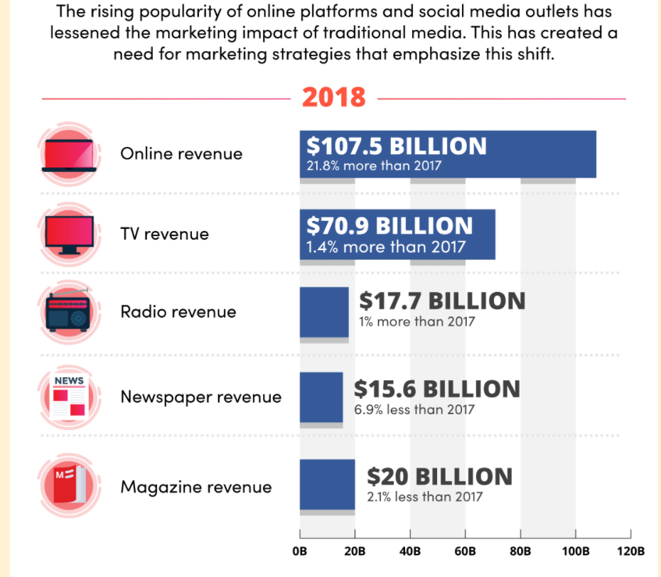

Figure - 2018 U.S. Digital Advertising

Although *Facebook* was created as a tool for connecting people, it is clearly a business and exists to make as much profit as possible, just like any media company, be it traditional or social. And what is becoming clearer, is the fact that social media platforms have moved ahead of their traditional counterparts when it comes to enticing advertising and marketing organisations. Print media has suffered the biggest revenue loss due to lack of demand from the new generation of consumers, and as stated, a major loss in interest from advertisers (Kaul, Vineet, 2020b).

While television, radio, and newspapers have targeted ‘users’with advertising for generations, and some of it could appear to be quite subliminal, an argument could easily be made that social media networks targeting of their ‘users’ may be seen as far more sinister with regards to their techniques. The tactic of manipulating ones emotions draws comparison with a sleight of hand trick that a magician would perform routinely. A notification followed by a posting, followed by a pop-up advert. All performed without many ‘users’ batting an eyelid. This is a powerful tool that traditional media platforms just can’t match in terms of interactivity and immediacy.

The end *goal* is to target the end *user*. If we are not buying the product, we *are* the product (McDavid, J. (2020) 'The Social Dilemma').

## 1.3 Citizen Journalists

Another disadvantage, in the opinion of *Radio Kerry* journalist, Mary Mullins, is the rise of *‘*Citizen Journalists*’*. Ordinary members of the public, with no formal training in journalism, who share news wide and far across social platforms without providing verification for these stories. This opens up the real possibility of, not only spreading falsehoods, but also committing libel and defamation due to their inexperience. Mullins feels that some citizen journalists may also cause irreparable damage to the relationship and trust which professional journalists build with the general public, as the audience may not realise that these stories are produced by someone with no recognised journalistic qualifications.

Journalism in traditional media, whether print or broadcast, is also regulated. There are defined ethics and guidelines for which journalists in these streams must adhere to. It is difficult to avoid the reality that social media platforms are unregulated, opening up many issues with citizen journalists broadcasting content which could be seen, for example, as morally reprehensible, or complete fabrication.

Another concern is the number of professional journalists losing their jobs. In 2012, *CNN* announced that it was cutting almost a dozen of its own staff due to the amount of footage gathered and received from citizen journalists (Arab spring leads surge in events captured on cameraphones, 2011).

Others see a beneficial side to the emergence of citizen journalists, though. Filmmaker, Peter Snowden, produced an anthology documenting footage of various events across the Middle East in what became known as, “The Uprising”. These pieces of raw, unedited, video captured historic, revolutionary moments which will go down in history for displaying a huge shift in power through countries such as Syria, Tunisia, Egypt, and more. “The Arab Spring” began at the start of the last decade as protestors battled for their rights against tyrannical governments, but if it wasn’t for citizen journalists, the movement, almost certainly, would not have been as successful as it was to become (‘The Uprising:’ The Arab Spring Through The Lenses of Citizen Journalists | Peacock Plume, 2021).

The ability to post these videos to social media platforms was pivotal in achieving greater freedoms for citizens of these Arab states. Faris Couri (then *BBC* Arabic editor) recalls the importance of citizen journalism during the conflicts.

“On the rare occasion journalists got access to Syria, they were accompanied by the authorities, so the unrestricted user content balanced the coverage. During the last year it became the norm, people realised the situation demands this and it’s impossible to rely on professionals.”

One of the better-known cases of citizen journalism was by Sohaib Athar, a Pakistani IT consultant who, inadvertently, commentated on the death of Taliban leader, Osama Bin Laden (Bin Laden raid was revealed on Twitter, 2011). Former political aid, Keith Urbahn tweeted (Figure 2) a little later to say that he had been informed of Bin Laden’s death, causing a viral spike in activity some 40 minutes before an official announcement was broadcast on television by President Obama (Wright, Paolo, 2020).

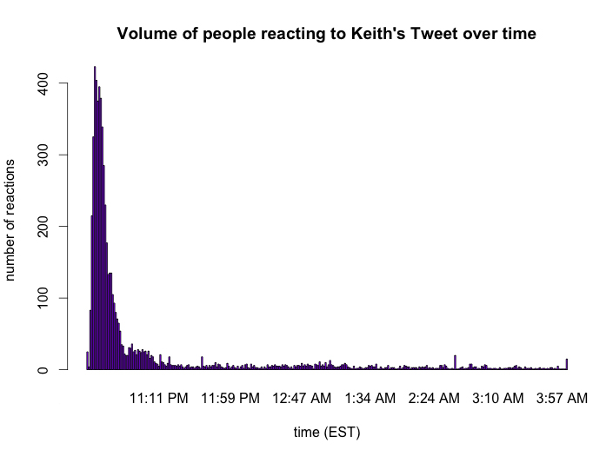

Figure - Twitter activity spike after Keith Urbahn's tweet

Many pronounced this as a significant moment in history, not just due to the death of such a notorious figure, but for the realisation that a social media platform had been so far ahead of its traditional rivals. Though, the author of the tweet, Urbahn, downplayed this by divulging the following.

“My source was a connected network TV producer. Stories about ‘the death of MSM’…are greatly exaggerated” (Bin Laden raid was revealed on Twitter, 2011).

Mainstream traditional media has come to embrace the concept of citizen journalism as it provides the most authentic footage available, and can also save on cost (Arab spring leads surge in events captured on cameraphones, 2011).

As shown in the passage above, there are definite advantages and disadvantages to citizen journalism, but it would appear to be here to stay.

# Chapter 2: Politics and Untruths

## 2.1 Introduction

Barack Obama’s astute strategy of reaching out to voters online, particularly *Facebook*, saw him rewarded with a landslide victory on his way to becoming President in the 2008 U.S. election. *BBC Question Time* guest, Brian Eno, called it as the first Presidency which had been won online (Dutta, 2008). It’s noticeable that outgoing President, Donald Trump, has had his term littered with controversy through his prolific tweeting. Social media has proven to be as much, if not more, of a political battleground than traditional media forms.

Aligned to the growth of the political and social media relationship has been the rapid emergence of disinformation. Although many would contend that politicians have been massaging the truth for decades in television interviews, the ease of accessibility to sites like *Twitter* has arguably seen witness to those in power being even more prolific with, what could be deemed as, ‘Untruths’. The fact that they don’t have a television or radio journalist to confront them ‘on air’ is very advantageous to them.

## 2.2 Political Usage

At its 2016 election peak, Donald Trump’s team, *Project Alamo*, was spending one million dollars per day on *Facebook* advertising. This would appear to prove just how vital political parties believe social media engagement to be, in terms of running a successful campaign.

This is further explored in the 2019 documentary, *“The Great Hack”*. Alexander Nix, CEO of *Cambridge Analytica*, realised just how crucial social media interaction would prove to be in terms of gaining political support, and his company went on to play a major role in the outcomes of elections worldwide. This was more obvious to those in the Western part of the world in relation to both the Trump and Brexit campaigns, but the “Do So” movement in Trinidad & Tobago displayed just how far reaching *Cambridge Analytica*’s skill in social media manipulation would travel (Amer, K. and Noujaim, J. (2019) *The great hack*. USA.).

*Cambridge Analytica*, *Google*, and many more companies, are able to gain valuable, sensitive, information belonging to ‘users’ by implementing complex algorithms to gather up as much data on the user as possible. This has long been done in conjunction with sites such as *Facebook*, eventually causing some sort of backlash amid the controversial methods. But much of this information morphed into manipulation and that is what political figures thrive upon. Once they can get an understanding of what the ‘user’ desires through that algorithm, it is a simple case of propagating their ideas into the ‘users’ conscious, back through the social media channels of choice. Cathy O’Neil (author – “*Weapons of Math Destruction*”) describes this tactic in 2020 documentary, *“The Social Dilemma”.*

“Algorithms are opinions embedded in code” (McDavid, J. (2020) 'The Social Dilemma', *Journal of Religion and Film*).

*Facebook* has also been found to be guilty of manipulating emotions in the form of sentiment analysis. Some would find this to be completely unethical and extremely dangerous to ‘users’ considered to be in a vulnerable state of mind (CallMiner, 2019).

Professor, Diarmaid Ferriter, on the danger of political tweets.

“They’re not in any way thoughtful, they’re not about a meaningful engagement; with the whole idea of evidence, or sources…and they do invite these distortions and simplifications.”

Ferriter adds;

“The tweets that are being used by politicians at the moment…they have to think about how they are communicating around very sensitive, and delicate issues”[4] (*Claire Byrne Live*. (2020), RTE One Television, 7 December).

## 2.3 Disinformation (“Fake news”)

Sandy Parakilas (former Operations Manager, *Facebook*) provides a fascinating quote in the 2020 documentary, “*The Social Dilemma*”.

“There’s a study from M.I.T. that fake news on twitter spreads six times faster than real news. False information makes the companies more money. The truth is boring” (McDavid, J. (2020) 'The Social Dilemma', *Journal of Religion and Film*).

During the recent 2020 U.S. Presidential elections, *Parler* grew in popularity amongst right-leaning Trump supporters who believed that mainstream media, and even mainstream social media platforms, were censoring material they believe to be worthy of being publicised. They believe the Trump rhetoric, that of the main media outlets pushing what he and his supporters would deem as, ‘Fake news’.

But many feel that it is *Parler*, itself, which is actually the spreader of such disinformation. The, seemingly unfounded, accusations of voter fraud are allowed to be published, unrestricted, on this platform. Famed conspiracy theories from the likes of the ‘QAnon’ movement are also heavily trended topics of discussion. Many far-right activists have set up accounts on the platform after being banned from social media sites such as *Twitter*. Controversial UK commentator, Katie Hopkins, is just one of those people, posting to her nearly half-a-million followers.

“Thank you to all my amazing supporters; here, online and in the streets” (On Parler, MAGA’s postelection world view blossoms with no pushback - POLITICO, 2021).

With so much controversy surrounding the issue of disinformation, the predominant social media channels have began to make real efforts into filtering content. *YouTube* is looking at increasing the context around conspiracy-led video content. *Twitter* has began to investigate alleged fake accounts. *WhatsApp* has restricted the use of its sharing functionality to under 10% of its previous ability. And *Facebook*’s Product Manager, Tessa Lyons, has outlined steps with which the platform intends to halt the spread of ‘fake news’.

“We also take action against entire pages and websites that repeatedly share false news. And since we don’t want to make money off of misinformation, or help those who create it profit, these publishers are not allowed to run ads or use our monetization features” (Lyons, Tessa, 2018).

Even mainstream, traditional media, including the *BBC* have implemented strategies such as ‘trust indicators’ (Figure 3) in the hope of differentiating themselves from sites which may appear to be less reputable (Figure 4). Fact-checking has become of huge importance in recent years (Learn how the BBC is working to strengthen trust and transparency in online news, 2021).

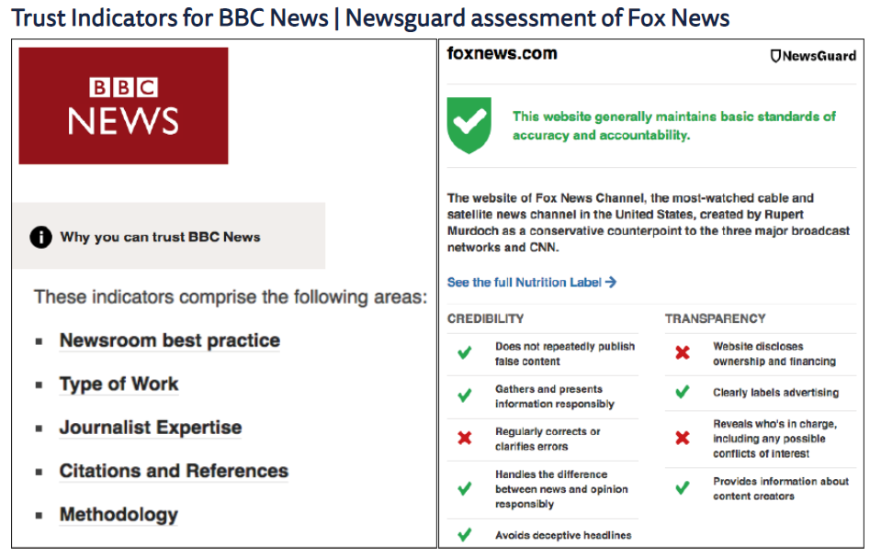

Figure - BBC Trust Indicator

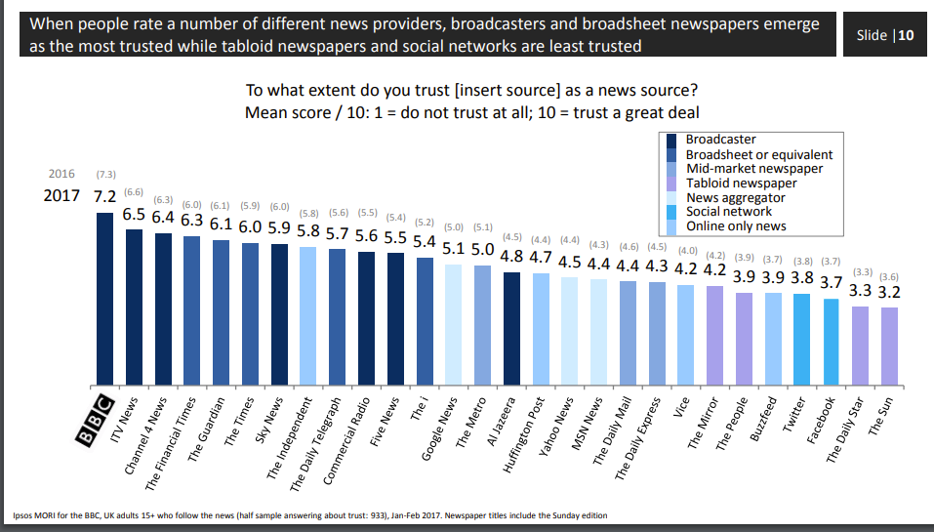

Figure - BBC Trust Poll

# Chapter 3: Automated Journalism & Artificial Intelligence

## 3.1 Introduction

Automated journalism has been used in the media industry for many years, but it is becoming more prevalent due to advances in the quality of technologies such as machine learning (Brennan, J. and Kleis Nielsen, Rasmus, 2020). Reputable organisations such as *Associated Press* have welcomed the model and this would appear to have given it some legitimacy within the industry. (Newman, Nick, 2019)

Meanwhile in Asia, television has adopted the use of artificial intelligence (AI) to good effect. (Newman, Nick, 2019)

AI is not without controversy, though, as its use in politics would seem to suggest. (Brennan, J. and Kleis Nielsen, Rasmus, 2020)

## 3.2 Impact on Traditional Media

The fear of losing their jobs has meant that many journalists will be feeling rather apprehensive towards the prospect of automated journalism, and AI, becoming more common. Damian Radcliff, Professor in Journalism at the University of Oregon, agrees that is a real possibility.

“Once developed not only can algorithms create thousands of news stories for a particular topic, they also do it more quickly, cheaply, and potentially with fewer errors than any human journalist”

Though it could be said that AI just doesn’t contain the capability of understanding, or replicating, human instinct (Galily, 2018).

Others feel that the technology is just not good enough yet, with one editor explaining that even with its benefits, AI is;

“Hopeless at actually writing stories” (Newman, Nick, 2020)

But the news organisations, themselves, would appear to be far more positive about the opportunities which could arise from the situation.

“It is a gift, offering us economic benefit and efficiency. It doesn’t replace journalists. It allows journalists to return to their primary function of breaking stories, uncovering facts, and delivering the news.” – National newspaper editor, Canada

And the London edition of *The Times*, with their slogan, make a clear effort to appease readers who are wary of the new technology and would rather good, old-fashioned, human writing. ‘Written by humans, curated by humans, distributed by robots’ (Newman, Nick, 2020).

In broadcasting terms, Asia would seem to be leading the way with *Xinhua*, state broadcaster of China introducing a virtual AI news anchor[5] (China’s Xinhua agency unveils AI news presenter, 2018), and Japan’s public broadcaster, *NHK*, creating anime presenters (Figure 3) (Are robots the journalists of the future?, 2021).

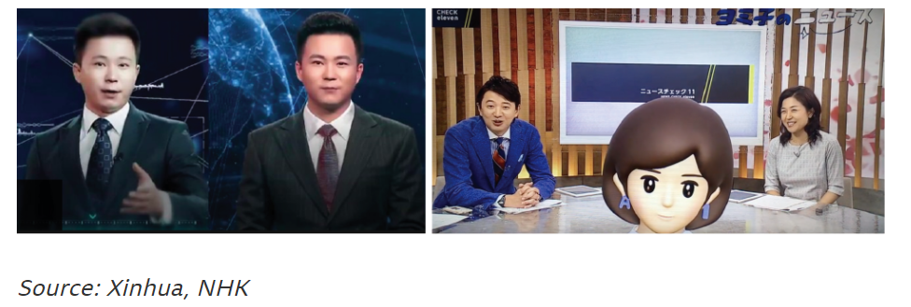

Figure 5 - AI newsreaders in Asia

In a 2019 survey conducted across 71 newsrooms using AI in 32 different countries, the key motives given for adopting the technologies was to supply more relevant content whilst improving the efficiency of both the business, and work of the journalists (Beckett, Charlie, 2019).

## 3.3 Controversy

As discussed earlier in this piece, disinformation has become a constant in the social media landscape, and the emergence of AI can seemingly make it even easier to produce ‘Fake news’ with the aid of simple algorithm processes. Both of the right, and left, leaning political movements are channelling AI tools to propagate topics such as ethics, discrimination, economics, and geopolitics (Brennan, J. and Kleis Nielsen, Rasmus, 2020).

University of Oregon’s professor in Journalism, Damian Radcliff is sceptical though, about the perceived lack of human input into the aforementioned algorithms.

“the robots are coming, but depending on the algorithm, the revolution may not be automatically published …” (Galily, 2018).

There is a real fear from traditional news outlets that the use of AI during election campaigns will provide misinformation in large quantities, once again, damaging the reputation of legitimate journalism as audiences struggle to separate the authors of such content (Newman, Nick, 2020)

# Conclusion

Considering the research and discussion provided throughout the paper, it seems clear that social media has become more prominent as each passing year goes by and has grasped the balance of power away from the traditional media *giants* of print and broadcast.

One of its main benefits appears to be its ease of use and access. The majority of the Western world, at least, will have access to smart phones. Because of this simplicity, anyone can become a journalist for a day. The interactivity this provides is seemingly unreachable to traditional media forms, and this has harmed them irreparably.

The rapid emergence and growth of disinformation is possibly not just a problem for media organisations, but for society as a whole. The use of ‘fake news’ over the past ten years in relation to controversial election campaigns, such as ‘Brexit’ and the U.S. election races of 2016 and 2020 would appear to have caused more division than ever before. The gap between left and right leaning members has seemingly widened, and the debates have become more hostile and vicious as social media engagement rises amongst the general public.

Going back generations, there would always have been a divide, a side taken. In the UK, T*he Sun* newspaper would almost always align itself to the *Conservative Party*. It’s often described American counterpart, *FOX News* constant backing of the *Republican Party*. But with the growth in popularity of social media platforms, these political contests appear to have become even more vitriolic, and further gaps between the wealthy and the poor in society seem to be noticeable.

This author has detected a shift in the medium of radio. There has always been the presence of ‘shock-jocks’ popping up sporadically in stations across the world, but in recent times, there is a sense that there now exists ‘shock-stations’. In the UK, *TalkRadio* thrives on its right-wing bias according to some. *Times Radio* is Rupert Murdoch’s latest venture, and even the formerly, inoffensive, *LBC* appears to attract its fair share of controversy.

In television, Andrew Neil, a long-time prominent power in the news industry, launches *GB News* shortly in what some are viewing as an attempt to steal an audience who have lost interest in the, supposedly, impartial *BBC*.

All of this would appear to be a reaction to the rise of social media channels. 24-hour news channels are essential now as these companies must keep up with *Twitter*. Radio feels that it must be controversial to compete with increasingly angry podcasters like Alex Jones. New media, it would appear, is only going to grow further, and so it is up to society to ensure that such growth doesn’t get to an uncontrollable scale.

# Tentative Predictions

Marshall McLuhan, the technological determinist stated.

“The Medium is the Message”

His implication was that the medium displaying the message was more important than the message itself. It can easily be seen how this quote still stands up today. We live in a world where, often, style over substance is the key to success.

We can narrow it down to an example in our own country, specifically politics. A sharp-suited, handsome to some, Leo Varadkar, could spin a complete pack of lies in Dáil Éireann. On the other side of the chamber, a somewhat scruffy appearing Mick Wallace, and Richard Boyd Barrett, wearing a typically un-ironed shirt, provide a counter statement of nothing but the truth. Facts, honesty, and integrity combined. But who does the public listen to?

I’m not saying the above is right, I have my own personal beliefs on the matter, but that is irrelevant. The point being made is that people often focus on *who* is supplying the information, sometimes bypassing the *actual* information altogether.

And that is why it is important for all media platforms, whether it be traditional print or broadcast, or social networks, to gain and keep the trust of their audience. How they do that can be morally ambiguous in the view of some. But this author doesn’t see their strategies changing anytime soon.

There is enough scope for all forms of these media to co-exist, certainly for the foreseeable future. Print appeals to an older audience, social to the youth. Television will always have an audience, even with competition from streaming services. And radio will adapt and change with the times as it always has done.

This author must admit, his reliance on having his phone close by at *all* times unnerves him. People have always enjoyed their traditional media, but social media seems to be bordering on levels of addiction for many. To finish a quote from Edward Tufte as it is a frighteningly accurate reflection on this topic;

“There are only two industries that call their customers ‘Users’; Illegal drugs and software” (McDavid, J. (2020) 'The Social Dilemma', *Journal of Religion and Film*).

# References

Anon 2011. *Arab spring leads surge in events captured on cameraphones*. [online] the Guardian. Available at: <http://www.theguardian.com/world/2011/dec/29/arab-spring-captured-on-cameraphones> [Accessed 7 Jan. 2021].

Anon 2011. Bin Laden raid was revealed on Twitter. *BBC News*. [online] 2 May. Available at: <https://www.bbc.com/news/technology-13257940> [Accessed 7 Jan. 2021].

Anon 2017. This week in tech. *The Telegraph*. [online] 1 Jun. Available at: <https://www.telegraph.co.uk/technology/connecting-britain/samuel-morse-sends-first-us-telegram/> [Accessed 5 Nov. 2020].

Anon 2018. China’s Xinhua agency unveils AI news presenter. *BBC News*. [online] 8 Nov. Available at: <https://www.bbc.com/news/technology-46136504> [Accessed 7 Jan. 2021].

Anon 2020. The Evolution of Social Media: How Did It Begin and Where Could It Go Next? *Maryville Online*. Available at: <https://online.maryville.edu/blog/evolution-social-media/> [Accessed 5 Nov. 2020].

Anon 2020. *USENET | Internet discussion network*. [online] Encyclopedia Britannica. Available at: <https://www.britannica.com/technology/USENET> [Accessed 5 Nov. 2020].

Anon 2021. *Are robots the journalists of the future?* [online] Reuters News Agency. Available at: <https://www.reutersagency.com/en/reuters-community/are-robots-the-journalists-of-the-future/> [Accessed 7 Jan. 2021].

Anon 2021. *Learn how the BBC is working to strengthen trust and transparency in online news*. [online] BBC News. Available at: <https://www.bbc.com/news/help-41670342> [Accessed 7 Jan. 2021].

Anon 2021. *On Parler, MAGA’s postelection world view blossoms with no pushback - POLITICO*. [online] Available at: <https://www.politico.com/news/2020/11/22/parler-maga-election-echo-chamber-439056> [Accessed 6 Jan. 2021].

Anon 2021. *‘The Uprising:’ The Arab Spring Through The Lenses of Citizen Journalists | Peacock Plume*. [online] Available at: <http://peacockplume.fr/campus/uprising-arab-spring-through-lenses-citizen-journalists> [Accessed 7 Jan. 2021].

Barnhart, Brent, 2020. *Social media and journalism: how to effectively reach the public*. [online] Sprout Social. Available at: <https://sproutsocial.com/insights/social-media-and-journalism/> [Accessed 4 Nov. 2020].

Barrero, M.a, 2018. Periodismo y drones. Retos y oportunidades del uso de drones para la narración informativa en España. *Doxa Comunicación. Revista interdisciplinar de estudios de comunicación y ciencias sociales*, 26, pp.35–58.

Beckett, Charlie, 2019. New powers, new responsibilities. A global survey of journalism and artificial intelligence. *Polis*. Available at: <https://blogs.lse.ac.uk/polis/2019/11/18/new-powers-new-responsibilities/> [Accessed 4 Nov. 2020].

Bolter, J.D. and Grusin, R.A., 1999. *Remediation: understanding new media*. Cambridge, Mass: MIT Press.

Brennan, J. and Kleis Nielsen, Rasmus, 2020. *An Industry-Led Debate: How UK Media Cover Artificial Intelligence*. [online] Reuters Institute for the Study of Journalism. Available at: <https://reutersinstitute.politics.ox.ac.uk/our-research/industry-led-debate-how-uk-media-cover-artificial-intelligence> [Accessed 4 Nov. 2020].

Brennen, J.S., Howard, P.N. and Nielsen, R.K., n.d. An Industry-Led Debate: How UK Media Cover Artificial Intelligence. p.10.

CallMiner, 2019. What is Sentiment Analysis? Examples, Best Practices, & More. *CallMiner*. Available at: <https://callminer.com/blog/sentiment-analysis-examples-best-practices/> [Accessed 6 Jan. 2021].

Carlson, N., 2020. *The Real History Of Twitter*. [online] Business Insider. Available at: <https://www.businessinsider.com/how-twitter-was-founded-2011-4> [Accessed 4 Nov. 2020].

Cote, Joe, 2020. *What is New Media?* [online] Available at: <https://www.snhu.edu/about-us/newsroom/2020/02/what-is-new-media> [Accessed 5 Nov. 2020].

Dutta, M.F.& S., 2008. *Obama’s win means future elections must be fought online*. [online] the Guardian. Available at: <http://www.theguardian.com/technology/2008/nov/07/barackobama-uselections2008> [Accessed 7 Jan. 2021].

Edosomwan, S., Prakasan, S.K., Kouame, D., Watson, J. and Seymour, T., 2011. The history of social media and its impact on business. *Journal of Applied Management and Entrepreneurship*, 16, pp.79–91.

Galily, Y., 2018. Artificial intelligence and sports journalism: Is it a sweeping change? *Technology in Society*, 54, pp.47–51.

Hall, Mark, 2020. *Facebook | Overview, History, & Facts*. [online] Encyclopedia Britannica. Available at: <https://www.britannica.com/topic/Facebook> [Accessed 4 Nov. 2020].

Kaul, Vineet, 2020a. *New Media, Part I: Redefining journalism : ACM - Computers in Entertainment*. [online] Available at: <https://cie.acm.org/articles/new-media-redefining-journalism/> [Accessed 3 Nov. 2020].

Kaul, Vineet, 2020b. *New Media, Part II: Redefining journalism : ACM - Computers in Entertainment*. [online] Available at: <https://cie.acm.org/articles/new-media-part-ii-redefining-journalism/index.html> [Accessed 3 Nov. 2020].

Lyons, Tessa, 2018. Hard Questions: What’s Facebook’s Strategy for Stopping False News? *About Facebook*. Available at: <https://about.fb.com/news/2018/05/hard-questions-false-news/> [Accessed 3 Nov. 2020].

McFadden, Christopher, 2020a. *A Chronological History of Social Media*. [online] Available at: <https://interestingengineering.com/a-chronological-history-of-social-media> [Accessed 5 Nov. 2020].

McFadden, Christopher, 2020b. *YouTube’s History and Its Impact on the Internet*. [online] Available at: <https://interestingengineering.com/youtubes-history-and-its-impact-on-the-internet> [Accessed 5 Nov. 2020].

*Me at the zoo*. 2005. Available at: <https://www.youtube.com/watch?v=jNQXAC9IVRw&feature=youtu.be> [Accessed 5 Nov. 2020].

Michel, Oscar, n.d. How Social Media has changed Journalism. *Irish Tech News*. Available at: <https://irishtechnews.ie/how-social-media-has-changed-journalism/> [Accessed 4 Nov. 2020].

Newman, Nick, 2019. *Journalism, Media and Technology Trends and Predictions 2019*. [online] Reuters Institute Digital News Report. Available at: <https://www.digitalnewsreport.org/publications/2019/journalism-media-technology-trends-predictions-2019/> [Accessed 3 Nov. 2020].

Newman, Nick, 2020. *Journalism, Media, and Technology Trends and Predictions 2020*. [online] Reuters Institute Digital News Report. Available at: <https://www.digitalnewsreport.org/publications/2020/journalism-media-and-technology-trends-and-predictions-2020/> [Accessed 4 Nov. 2020].

Newman, Nick, 2020. *The rise of social media and its impact on mainstream journalism - ORA - Oxford University Research Archive*. [online] Available at: <https://ora.ox.ac.uk/objects/uuid:a980df14-1b49-401b-a136-78d47ab76cdc> [Accessed 5 Nov. 2020].

Potter, James, 2014. The History of LinkedIn. *The Linked In Man*. Available at: <https://thelinkedinman.com/history-linkedin/> [Accessed 5 Nov. 2020].

Rosenwald, M.S., n.d. Before Twitter and Facebook, there was Morse code: Remembering social media’s true inventor. *Washington Post*. [online] Available at: <https://www.washingtonpost.com/news/retropolis/wp/2017/05/24/before-there-was-twitter-there-was-morse-code-remembering-social-medias-true-inventor/> [Accessed 5 Nov. 2020].

Wang, Y. and Cao, Y., 2019. Research on Interactive Journalism in the Background of Big Data, Virtual Reality Technology and Media Convergence. In: *2019 IEEE/ACIS 18th International Conference on Computer and Information Science (ICIS)*. 2019 IEEE/ACIS 18th International Conference on Computer and Information Science (ICIS). pp.478–482.

Wright, Paolo, 2020. *Propagation of the news of OBL’s death via Twitter*. [online] Revolutions. Available at: <https://blog.revolutionanalytics.com/2011/05/propagation-of-the-news-of-obls-death-via-twitter.html> [Accessed 3 Nov. 2020].

**Works Cited**

# Bibliography

Anon 2011. *Arab spring leads surge in events captured on cameraphones*. [online] the Guardian. Available at: <http://www.theguardian.com/world/2011/dec/29/arab-spring-captured-on-cameraphones> [Accessed 7 Jan. 2021].

Anon 2011. Bin Laden raid was revealed on Twitter. *BBC News*. [online] 2 May. Available at: <https://www.bbc.com/news/technology-13257940> [Accessed 7 Jan. 2021].

Anon 2017. This week in tech. *The Telegraph*. [online] 1 Jun. Available at: <https://www.telegraph.co.uk/technology/connecting-britain/samuel-morse-sends-first-us-telegram/> [Accessed 5 Nov. 2020].

Anon 2018. China’s Xinhua agency unveils AI news presenter. *BBC News*. [online] 8 Nov. Available at: <https://www.bbc.com/news/technology-46136504> [Accessed 7 Jan. 2021].

Anon 2020. The Evolution of Social Media: How Did It Begin and Where Could It Go Next? *Maryville Online*. Available at: <https://online.maryville.edu/blog/evolution-social-media/> [Accessed 5 Nov. 2020].

Anon 2020. *USENET | Internet discussion network*. [online] Encyclopedia Britannica. Available at: <https://www.britannica.com/technology/USENET> [Accessed 5 Nov. 2020].

Anon 2021. *Are robots the journalists of the future?* [online] Reuters News Agency. Available at: <https://www.reutersagency.com/en/reuters-community/are-robots-the-journalists-of-the-future/> [Accessed 7 Jan. 2021].

Anon 2021. *BibGuru*. [online] Available at: <https://app.bibguru.com/p/0d4efec3-5869-4240-bc76-9e4d691f5744> [Accessed 6 Jan. 2021].

Anon 2021. *Learn how the BBC is working to strengthen trust and transparency in online news*. [online] BBC News. Available at: <https://www.bbc.com/news/help-41670342> [Accessed 7 Jan. 2021].

Anon 2021. *On Parler, MAGA’s postelection world view blossoms with no pushback - POLITICO*. [online] Available at: <https://www.politico.com/news/2020/11/22/parler-maga-election-echo-chamber-439056> [Accessed 6 Jan. 2021].

Anon 2021. *‘The Uprising:’ The Arab Spring Through The Lenses of Citizen Journalists | Peacock Plume*. [online] Available at: <http://peacockplume.fr/campus/uprising-arab-spring-through-lenses-citizen-journalists> [Accessed 7 Jan. 2021].

Anon n.d. *bbc_report_trust_and_impartiality_nov_2017.pdf*.

Anon n.d. *bbc_report_trust_and_impartiality_nov_2017.pdf*. Available at: <https://downloads.bbc.co.uk/aboutthebbc/insidethebbc/howwework/reports/pdf/bbc_report_trust_and_impartiality_nov_2017.pdf> [Accessed 7 Jan. 2021b].

Anon n.d. *The rise of social media and its impact on mainstream journalism.pdf*. Available at: <https://reutersinstitute.politics.ox.ac.uk/sites/default/files/2017-11/The%20rise%20of%20social%20media%20and%20its%20impact%20on%20mainstream%20journalism.pdf> [Accessed 4 Nov. 2020].

Arthur, Charles, 2010. How Twitter was born: the first 140 users. *The Guardian*. [online] 11 Jan. Available at: <https://www.theguardian.com/technology/blog/2010/jan/11/twitter-first-140-users-history> [Accessed 4 Nov. 2020].

Barnhart, Brent, 2020. *Social media and journalism: how to effectively reach the public*. [online] Sprout Social. Available at: <https://sproutsocial.com/insights/social-media-and-journalism/> [Accessed 4 Nov. 2020].

Barrero, M.a, 2018. Periodismo y drones. Retos y oportunidades del uso de drones para la narración informativa en España. *Doxa Comunicación. Revista interdisciplinar de estudios de comunicación y ciencias sociales*, 26, pp.35–58.

Beckett, Charlie, 2019. New powers, new responsibilities. A global survey of journalism and artificial intelligence. *Polis*. Available at: <https://blogs.lse.ac.uk/polis/2019/11/18/new-powers-new-responsibilities/> [Accessed 4 Nov. 2020].

Beckett, Charlie, 2020. .*New powers, new responsibilities | The Journalism AI report.pdf*. [online] Google Docs. Available at: <https://drive.google.com/file/d/1utmAMCmd4rfJHrUfLLfSJ-clpFTjyef1/view?usp=drive_open&usp=embed_facebook> [Accessed 4 Nov. 2020].

Bolter, J.D. and Grusin, R.A., 1999. *Remediation: understanding new media*. Cambridge, Mass: MIT Press.

Brennan, J. and Kleis Nielsen, Rasmus, 2020. *An Industry-Led Debate: How UK Media Cover Artificial Intelligence*. [online] Reuters Institute for the Study of Journalism. Available at: <https://reutersinstitute.politics.ox.ac.uk/our-research/industry-led-debate-how-uk-media-cover-artificial-intelligence> [Accessed 4 Nov. 2020].

Brennen, J.S., Howard, P.N. and Nielsen, R.K., n.d. An Industry-Led Debate: How UK Media Cover Artificial Intelligence. p.10.

Brown, H., Guskin, E. and Mitchell, A., 2012. The Role of Social Media in the Arab Uprisings. *Pew Research Center’s Journalism Project*. Available at: <https://www.journalism.org/2012/11/28/role-social-media-arab-uprisings/> [Accessed 7 Jan. 2021].

CallMiner, 2019. What is Sentiment Analysis? Examples, Best Practices, & More. *CallMiner*. Available at: <https://callminer.com/blog/sentiment-analysis-examples-best-practices/> [Accessed 6 Jan. 2021].

Carlson, N., 2020. *The Real History Of Twitter*. [online] Business Insider. Available at: <https://www.businessinsider.com/how-twitter-was-founded-2011-4> [Accessed 4 Nov. 2020].

*Claire Byrne Live Diarmaid Ferriter Dec 7th 2020*. 2021. Colm Gallagher Available at: <https://www.youtube.com/watch?v=2KzIiwWgMxM> [Accessed 7 Jan. 2021].

Cote, Joe, 2020. *What is New Media?* [online] Available at: <https://www.snhu.edu/about-us/newsroom/2020/02/what-is-new-media> [Accessed 5 Nov. 2020].

Dutta, M.F.& S., 2008. *Obama’s win means future elections must be fought online*. [online] the Guardian. Available at: <http://www.theguardian.com/technology/2008/nov/07/barackobama-uselections2008> [Accessed 7 Jan. 2021].

Edosomwan, S., Prakasan, S.K., Kouame, D., Watson, J. and Seymour, T., 2011. The history of social media and its impact on business. *Journal of Applied Management and Entrepreneurship*, 16, pp.79–91.

Galily, Y., 2018. Artificial intelligence and sports journalism: Is it a sweeping change? *Technology in Society*, 54, pp.47–51.

Hall, Mark, 2020. *Facebook | Overview, History, & Facts*. [online] Encyclopedia Britannica. Available at: <https://www.britannica.com/topic/Facebook> [Accessed 4 Nov. 2020].

Kaul, Vineet, 2020a. *New Media, Part I: Redefining journalism : ACM - Computers in Entertainment*. [online] Available at: <https://cie.acm.org/articles/new-media-redefining-journalism/> [Accessed 3 Nov. 2020].

Kaul, Vineet, 2020b. *New Media, Part II: Redefining journalism : ACM - Computers in Entertainment*. [online] Available at: <https://cie.acm.org/articles/new-media-part-ii-redefining-journalism/index.html> [Accessed 3 Nov. 2020].

Kim, D. and Kim, S., 2017. Newspaper companies’ determinants in adopting robot journalism. *Technological Forecasting and Social Change*, 117, pp.184–195.

Kim, D. and Kim, S., 2018. Newspaper journalists’ attitudes towards robot journalism. *Telematics and Informatics*, 35(2), pp.340–357.

Laor, T. and Galily, Y., 2020. Offline VS online: Attitude and behavior of journalists in social media era. *Technology in Society*, 61, p.101239.

Lindner, A.M. and Larson, R.P., 2017. The expansion and contraction of the journalistic field and American online citizen journalism, 2000–2012. *Poetics*, 64, pp.40–52.

Lister, M., 2008. *New Media: A Critical Introduction*. 2nd ed. [online] Routledge. Available at: <https://www.taylorfrancis.com/books/9780203884829> [Accessed 4 Nov. 2020].

Lyons, Tessa, 2018. Hard Questions: What’s Facebook’s Strategy for Stopping False News? *About Facebook*. Available at: <https://about.fb.com/news/2018/05/hard-questions-false-news/> [Accessed 3 Nov. 2020].

McDavid, J., 2020. The Social Dilemma. *Journal of Religion and Film*, 24(1), pp.COV41–COV41.

McFadden, Christopher, 2020a. *A Chronological History of Social Media*. [online] Available at: <https://interestingengineering.com/a-chronological-history-of-social-media> [Accessed 5 Nov. 2020].

McFadden, Christopher, 2020b. *YouTube’s History and Its Impact on the Internet*. [online] Available at: <https://interestingengineering.com/youtubes-history-and-its-impact-on-the-internet> [Accessed 5 Nov. 2020].

*Me at the zoo*. 2005. Available at: <https://www.youtube.com/watch?v=jNQXAC9IVRw&feature=youtu.be> [Accessed 5 Nov. 2020].

Michel, Oscar, n.d. How Social Media has changed Journalism. *Irish Tech News*. Available at: <https://irishtechnews.ie/how-social-media-has-changed-journalism/> [Accessed 4 Nov. 2020].

*New powers, new responsibilities: Journalism and artificial intelligence*. 2019. Available at: <https://www.youtube.com/watch?v=p-DGp1ot0EE> [Accessed 4 Nov. 2020].

Newman, Nick, 2019. *Journalism, Media and Technology Trends and Predictions 2019*. [online] Reuters Institute Digital News Report. Available at: <https://www.digitalnewsreport.org/publications/2019/journalism-media-technology-trends-predictions-2019/> [Accessed 3 Nov. 2020].

Newman, Nick, 2020. *Journalism, Media, and Technology Trends and Predictions 2020*. [online] Reuters Institute Digital News Report. Available at: <https://www.digitalnewsreport.org/publications/2020/journalism-media-and-technology-trends-and-predictions-2020/> [Accessed 4 Nov. 2020].

Newman, Nick, 2020. *The rise of social media and its impact on mainstream journalism - ORA - Oxford University Research Archive*. [online] Available at: <https://ora.ox.ac.uk/objects/uuid:a980df14-1b49-401b-a136-78d47ab76cdc> [Accessed 5 Nov. 2020].

Potter, James, 2014. The History of LinkedIn. *The Linked In Man*. Available at: <https://thelinkedinman.com/history-linkedin/> [Accessed 5 Nov. 2020].

Rosenwald, M.S., n.d. Before Twitter and Facebook, there was Morse code: Remembering social media’s true inventor. *Washington Post*. [online] Available at: <https://www.washingtonpost.com/news/retropolis/wp/2017/05/24/before-there-was-twitter-there-was-morse-code-remembering-social-medias-true-inventor/> [Accessed 5 Nov. 2020].

Team, I.L., 2021. *IOE LibGuides: Referencing with Harvard: Television programme*. [online] Available at: <https://libguides.ioe.ac.uk/c.php?g=482485&p=3299851> [Accessed 7 Jan. 2021].

Thaker, A., 2020. *WhatsApp is now betting on Indian primetime television to fight fake news*. [online] Quartz India. Available at: <https://qz.com/india/1482656/whatsapp-launches-tv-ad-campaign-to-fight-fake-news-in-india/> [Accessed 3 Nov. 2020].

Tutgun-Ünal, A., 2020. Social Media Addiction of New Media and Journalism Students. *Turkish Online Journal of Educational Technology - TOJET*, 19(2), pp.1–12.

Wang, Y. and Cao, Y., 2019. Research on Interactive Journalism in the Background of Big Data, Virtual Reality Technology and Media Convergence. In: *2019 IEEE/ACIS 18th International Conference on Computer and Information Science (ICIS)*. 2019 IEEE/ACIS 18th International Conference on Computer and Information Science (ICIS). pp.478–482.

Wilding, D., n.d. The Impact of Digital Platforms on News and Journalistic Content. p.175.

Wright, Paolo, 2020. *Propagation of the news of OBL’s death via Twitter*. [online] Revolutions. Available at: <https://blog.revolutionanalytics.com/2011/05/propagation-of-the-news-of-obls-death-via-twitter.html> [Accessed 3 Nov. 2020].

Zheng, Y., Zhong, B. and Yang, F., 2018. When algorithms meet journalism: The user perception to automated news in a cross-cultural context. *Computers in Human Behavior*, 86, pp.266–275.

1. Originally named “Twttr”
2. At time of writing, though he has since, reluctantly, conceded defeat to President elect, Joe Biden.
3. Link to view this interview - https://youtu.be/2KzIiwWgMxM
4. Link to view this interview - https://youtu.be/2KzIiwWgMxM
5. Link to video of virtual news anchor - https://www.bbc.com/news/technology-46136504